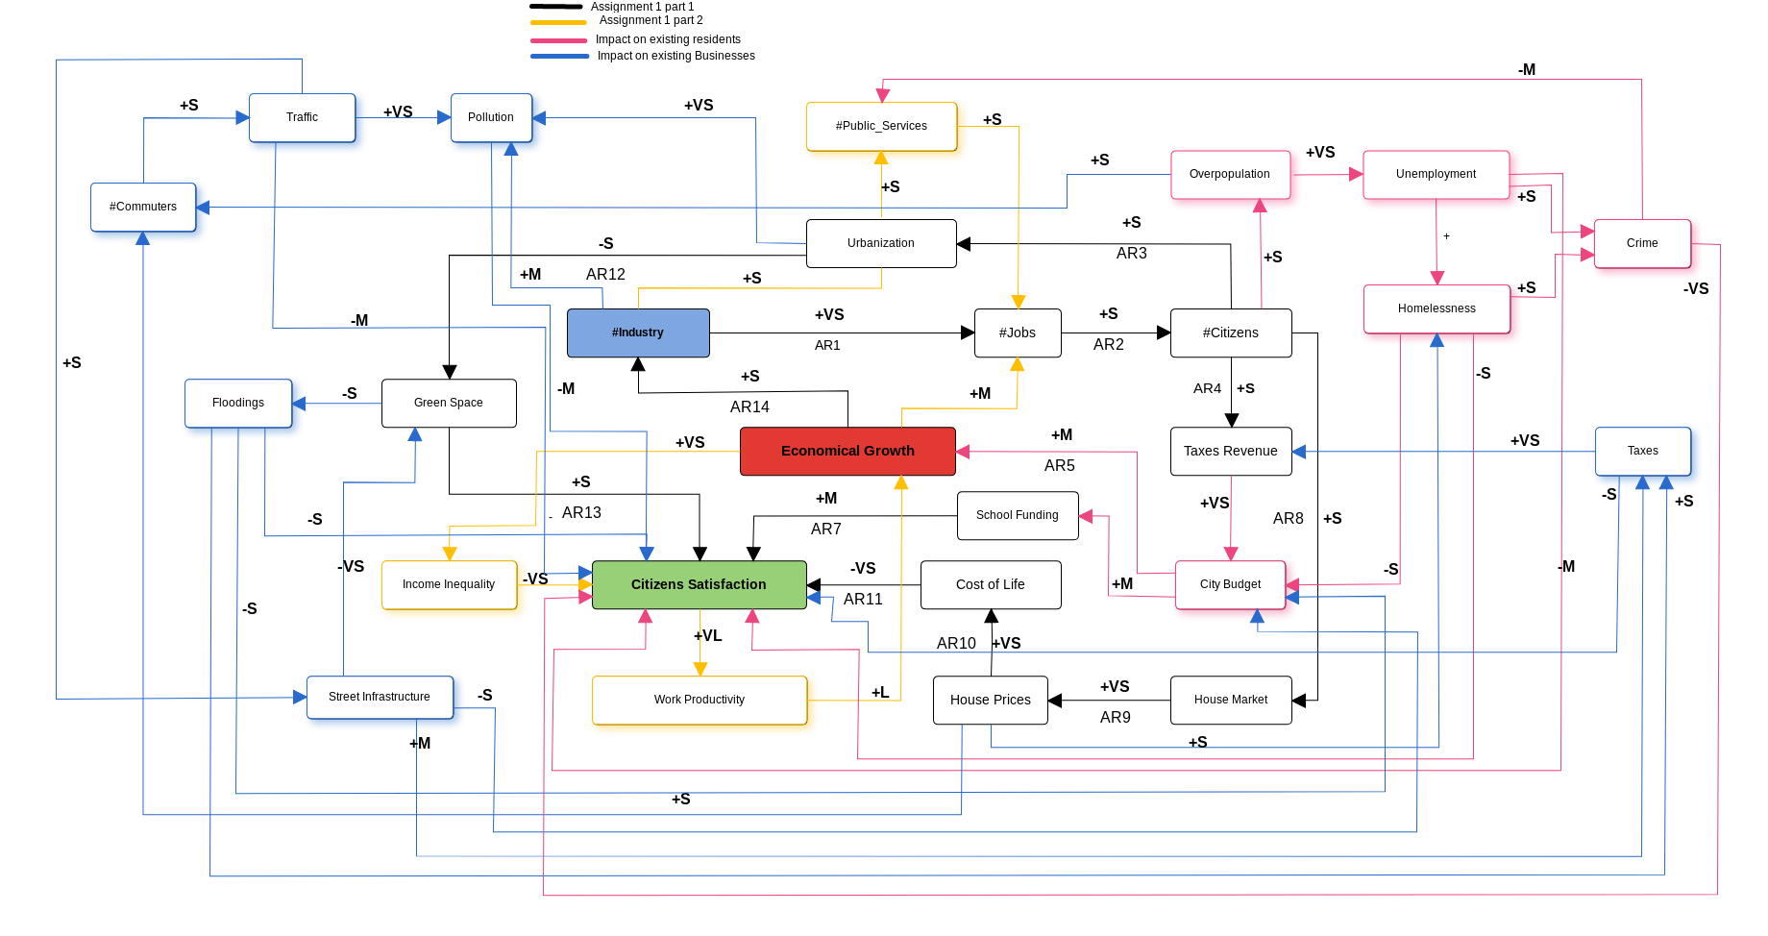
Impact on current residents.

The first reading about the impact of the new company on the city gave me some additional point of views that I thought were not relevant for the outcome of the simulation. I decided to stop at a certain level of detail thinking that it might have been enough, but some of those events affect a lot the outcome of the model.
First of all my old graph didn’t have anything to represent the budget of the city, I had represented the tax revenue which should be considered just as a quantity to show the income of the city, but that can’t substitute the liquidity of the city.
Also, the reading touched on problems that I might not have thought about given the nature of the first assignment.
The assignment specified that an online retailer wanted to build his new headquarter in the city, but never mentioned that most of the positions available in the company would have required specialized skills. Being Libertville a small city, most of the people living there wouldn’t have those skills, resulting in people from outside the city to move in and get those jobs.
Overpopulation, employment, and homelessness drove an increase of the criminality in the city. In the same manner this led many grocery stores (public services) to move their businesses out of town, and lowered the satisfaction of the residents of Libertville.

Nodes and edges added:

graph.add_edge("#Citizens","Overpopulation",{"direction":'+S'})
graph.add_edge("#Overpopulation","Unemployment",{"direction":'+VS'})
graph.add_edge("Unemployment","Crime",{"direction":'+S'})
graph.add_edge("Unemployment","Homelessness",{"direction":'+S'})
graph.add_edge("Unemployment","Citizens_Satisfaction",{"direction":'-M'})
graph.add_edge("Homelessness","City_Budget",{"direction":'-S'})
graph.add_edge("Homelessness","Citizens_Satisfaction",{"direction":'-S'})
graph.add_edge("Crime","#Public_Services",{"direction":'-M'})
graph.add_edge("City_Budget","School_Funding",{"direction":'+M'})
graph.add_edge("City_Budget","Economical_Growth",{"direction":'+M'})
graph.add_edge("Crime","Citizens_Satisfaction",{"direction":'+VS'})

Impact on existing businesses

The second reading focused more on the impact that the business had on the city.
It focuses on all the changes that the city had to do to accommodate the new company and the new citizens. It also discusses about problems that were fixed after the arrival of the online retailer, problems not yet fixed and what it’s going to cost to the city to get it done.
Having the city sold green spaces to the companies entering in the city, the city is now prone to floodings. The remaining green land can’t absorb anymore all the raining water.
Due to the increase of the citizens in the city, the major had to improve the street infrastructure of the city.
Resolving the problem of the floods, and improving the street infrastructure of the city, had a big impact on the budget of the city. This forced to increase the taxes to pay for the expenses, thing that the citizens didn’t like.
Also due to the increasing price of houses, more and more people were forced to live outside of town, where the cost of the houses was lower. This forced many people to commute to work in town, increasing the traffic in the city and the smog generated.

Nodes and edges added:

graph.add_edge("Overpopulation","#Commuters",{"direction":'+S'})
graph.add_edge("#Commuters","Traffic",{"direction":'+S'})
graph.add_edge("Traffic","Pollution",{"direction":'+VS'})
graph.add_edge("Pollution","Citizens_Satisfaction",{"direction":'-M'})
graph.add_edge("Urbanization","Pollution",{"direction":'+VS'})
graph.add_edge("#Industry","Pollution",{"direction":'+M'})
graph.add_edge("Traffic","Street_Infrastructure",{"direction":'+S'})
graph.add_edge("Street_Infrastructure","City_Budget",{"direction":'-S'})
graph.add_edge("Street_Infrastructure","Taxes",{"direction":'+M'})
graph.add_edge("Street_Infrastructure","Green_Spaces",{"direction":'-VS'})
graph.add_edge("Green_Spaces","Floodings",{"direction":'-S'})
graph.add_edge("Floodings","Citizens_Satisfaction",{"direction":'-S'})
graph.add_edge("Floodings","City_Budget",{"direction":'-S'})
graph.add_edge("Floodings","Taxes",{"direction":'+S'})
graph.add_edge("House_Prices","#Commuters",{"direction":'+S'})
graph.add_edge("Taxes","Tax_Revenue",{"direction":'+VS'})
graph.add_edge("Taxes","Citizens_Satisfaction",{"direction":'-S'})
graph.add_edge("Traffic","Citizens_Satisfaction",{"direction":'-M'})
graph.add_edge("House_Prices","Homelessness",{"direction":'+S'})

Overall Consideration

Both the paragraph expanded two different ideas of the graph.
The first paragraph was focused on the status of the citizens of the city, meanwhile the second paragraph was focused on the city itself.
Both the stories allowed me to understand deeply the possible causes and effects of each course of action, allowing me to expand my graph further. I was not sure on how much I had to go in detail on the representation of the map, so I limited myself on the assignment 1 part 1 to include just what could have been extrapolated from the text, adding just the house market, house prices and cost of living to the graph as something I thought about.
In the assignment 1 part 2, after calculating the centrality I realized that the graph was unbalanced on what effect the company would bring on the citizens of Libertville and I unintentionally developed more the citizen side of the map and not the city evolution with its effects.
This led the Katz centrality to be focused on the number of citizens.
After some changes, expanding further the effect on the city, I was able to re-balance the graph, and obtain a centrality focused on the economical growth of the city.
With the new changes to the map, and applying again the Katz centrality algorithm to the graph, the new results obtained are:

[('Citizens_Satisfaction', 0.32155243352916674),
('City_Budget', 0.22904692668463875),
('Urbanization', 0.21026156030458856),
('Floodings', 0.208848373077106),
('Economical_Growth', 0.2072475118957641),
('Green_Spaces', 0.2065700285371766),
('Pollution', 0.20559058313684014),
('Homelessness', 0.20537565387860932),
('Taxes', 0.2031522402424063),
('Traffic', 0.20182643984809276),
('#Citizens', 0.20047510218809222),
('Street_Infrastructure', 0.19687578345316253),
('#Industry', 0.1941032217232805),
('Unemployment', 0.19362186636633164),
('#Jobs', 0.18977026154506393),
('House_Prices', 0.18137313091509627),
('Tax_Revenue', 0.17608366020728278),
('School_Funding', 0.1678761646828742),
('#Public_Services', 0.1677144128953351),
('#Commuters', 0.16608340969039187),
('Work_Productivity', 0.1656962262171621),
('Income_Inequality', 0.1656962262171621),
('Cost_of_Life', 0.1631087908969316),
('House_Market', 0.15100107144985894),
('Overpopulation', 0.14947210025715982),
('Crime', 0.148949874860568),
('#Overpopulation', 0.1321784364684093)]
The Citizens satisfaction is now the focal point of the graph.

